Analú López
LIS704-Reference and Online Services
Professor Geoffrey Greenberg
April 27, 2015

Carl Sagan: A Subject Guide
http://carlsaganlovers.weebly.com

The following subject guide is about Carl Sagan, his career, contributions and some information on Astronomy and Physics. The intended audience for this subject guide is high school to college undergraduates interested in pursuing astronomy or just interested in the topic and Carl Sagan.

Background on Carl Sagan

Carl Edward Sagan (/ˈseɪɡən/; November 9, 1934 – December 20, 1996) was an American astronomer, cosmologist, astrophysicist, astrobiologist, author, science popularizer, and science communicator in astronomy and other natural sciences. Sagan was born in Brooklyn, New York. His father, Samuel Sagan, was an immigrant garment worker from Kamianets-Podilskyi, then Russian Empire, in today's Ukraine. His mother, Rachel Molly Gruber, was a housewife from New York. Carl was named in honor of Rachel's biological mother, Chaiya Clara, in Sagan's words, "the mother she never knew." Sagan graduated from Rahway High School in Rahway, New Jersey in 1951.

His contributions were central to the discovery of the high surface temperatures of Venus. However, he is best known for his contributions to the scientific research of extraterrestrial life, including experimental demonstration of the production of amino acids from basic chemicals by radiation. Sagan assembled the first physical messages that were sent into space: the Pioneer plaque and the Voyager Golden Record, universal messages that could potentially be understood by any extraterrestrial intelligence that might find them.

He attended the University of Chicago, where he participated in the Ryerson Astronomical Society,^{[11]} received a B.A. degree in self-proclaimed "nothing" with general and special honors in 1954, a B.S. degree in physics in 1955, and an M.S. degree in physics in 1956, before earning a Ph.D. degree in 1960 with the dissertation "Physical Studies of Planets" submitted to the Department of Astronomy and Astrophysics.

The best book on the subject of Science and God, by far, is The Varieties of Scientific Experience: A Personal View of the Search for God (public library) — a remarkable posthumous collection of essays by Carl Sagan, based on the prestigious Gifford Lectures on Natural Theology he delivered at the university of Glasgow in 1985.

In that same drawer where the transcript of these lectures (Varieties of Scientific Experience: Carl Sagan on Science and God) was rediscovered, there was a sheaf of notes intended for a book we never had the chance to write. Its working title was Ethos, and it would have been our attempt to synthesize the spiritual perspectives we derived from the revelations of science. We collected filing cabinets’ worth of notes and references on the subject. Among them was a quotation Carl had excerpted from Gottfried Wilhelm Leibniz (1646–1716), the mathematical and philosophical genius, who had invented differential and integral calculus independently of Isaac Newton. Leibniz argued that God should be the wall that stopped all further questioning, as he famously wrote in this passage from Principles of Nature and Grace:

“Why does something exist rather than nothing? For ‘nothing’ is simpler than ‘something.’ Now this sufficient reason for the existence of the universe…which has no need of any other reason…must be a necessary being, else we should not have a sufficient reason with which we could stop.”
And just beneath the typed quote, three small handwritten words in red pen, a message from Carl to Leibniz and to us:
“So don’t stop.
CIRCULATING BOOKS: Required: 8 -10 annotated
- Sagan, Carl. Pale Blue Dot: A Vision of the Human Future in Space. New York: Random House, 1994. Print. pp. 384
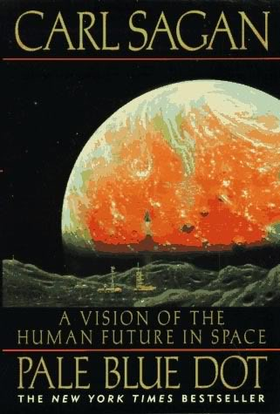 | Summary:  Sagan's great appeal as a popular-science writer, beyond his prodigious knowledge, is his optimism and sense of wonder. A visualizer and a visionary, he fires our imagination and turns science into high drama. After writing about our origins in Shadows of Forgotten Ancestors (1992), Sagan turns his attention to outer space and takes up where Cosmos left off 14 years ago.  An astonishing amount of information was amassed during that productive era, and Sagan, of course, is up on all of it. A passionate and eloquent advocate of space exploration, he believes that the urge to wander, and the need for a frontier, is intrinsic to our nature, and that this trait is linked to our survival as a species.  Throughout this beautifully illustrated, revelatory, and compelling volume, Sagan returns again and again to our need for journeys and quests as well as our unending curiosity about our place in the universe. Such philosophical musings are interwoven with precise and enthusiastic accounts of the triumphs of interplanetary exploration, from the Apollo moon landings to the spectacular findings of robotic missions, especially the Voyager spacecraft. Sagan describes one exciting discovery after another regarding the four giants--Jupiter, Saturn, Uranus, and Neptune--and their many moons, mysterious and exquisite rings, and volatile atmospheres. He argues, convincingly, that planetary exploration is of immense value. It not only teaches us about our celestial neighbors, but helps us understand and protect Earth. Yes, we have seemingly insurmountable problems on this pale blue dot, but we have always reached for the stars, and we mustn't stop now. Donna Seaman --This text refers to an out of print or unavailable edition of this title.

- Davidson, Keay. Carl Sagan: A Life. New York: J. Wiley, c1999. Print. pp. 54o
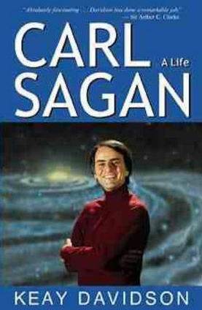 | Summary:  Carl Sagan was one of the most celebrated scientists of this century-the handsome and alluring visionary who inspired a generation to look to the heavens and beyond. His life was both an intellectual feast and an emotional rollercoaster. Based on interviews with Sagan's family and friends, including his widow, Ann Druyan; his first wife, acclaimed scientist Lynn Margulis; and his three sons, as well as exclusive access to many personal papers, this highly acclaimed life story offers remarkable insight into one of the most influential, provocative, and beloved figures of our time-a complex, contradictory prophet of the Space Age.  In a superbly researched biography of one of the 20the century's most influential yet controversial scientists, Davidson (coauthor, Wrinkles in Time) leaves no doubt about where he feels his subject stands. "What is a visionary?" he asks in the closing chapter.  "Carl Sagan measured time in eons and space in light years; he maintained an interplanetary perspective." Though many of Davidson's anecdotes echo those in William Poundstone's Carl Sagan: A Life in the Cosmos, he actively guides readers to conclusions, where Poundstone merely lays out the facts. Though not avoiding Sagan's many failings as a person, Davidson never allows his readers to lose sight of the grand visions, brilliant insights and brash speculations that inspired and educated Sagan's audiences. The book is at its strongest when it shows the inner Sagan through his most influential works: the Pulitzer Prize-winning Dragons of Eden; the Emmy and Peabody Award-winning television series Cosmos; his SF novel Contact; and his scientific publications about the runaway greenhouse effect on Venus, the windblown dust responsible for "waves of darkening" on Mars and the threat of "nuclear winter" after a limited nuclear war on earth. The volume is weakest when, instead of holding Sagan responsible for his sometimes, arrogant behavior, it offers excuses from pop psychology. Though nonscientific readers may find Davidson's biography sufficient, naturally skeptical scientific readers may find its conclusions too firm for comfort. They should read Poundstone first, then turn to Davidson to complete the picture. (Sept.) (c) Copyright PWxyz, LLC. All rights reserved

- Poundstone, William. A Life in the Cosmos. New York: Henry Holt, c1999. Print. pp473.
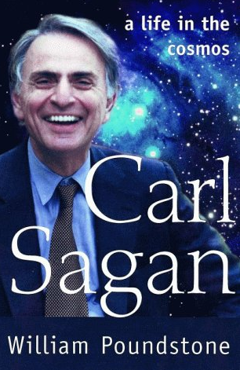 | Summary:  The first biography of the best-known scientist of his generation and the author of the best-seller Cosmos. In this, the first full-scale examination of the life of Carl Sagan, award-winning science writer William Poundstone details the transformation of a bookish young astronomer obsessed with life on other worlds into science's first authentic media superstar. As a fixture on television and a bestselling author, Sagan became instantly recognizable. To people around the world, he offered entrée into the mysteries of the cosmos and of science in general. To much of the scientific community,though, he was something of a pariah, a brazen publicity seeker who cared more about his image and his fortune than the advancement of science. Poundstone reveals the seldom-discussed aspects of Sagan's life, the legitimate and important work of his early scientific career, the almost obsessive capacity to take on less projects, the multiple marriages and fractured tumultuous personal life-all essential elements of this complicated and extraordinary man, truly the first and most famous scientist of the media age.

- Sagan, Carl. The Varieties of Scientific Experience: A Personal view of the Search for God. New York: Penguin Press, 2006. Print. pp. 284.
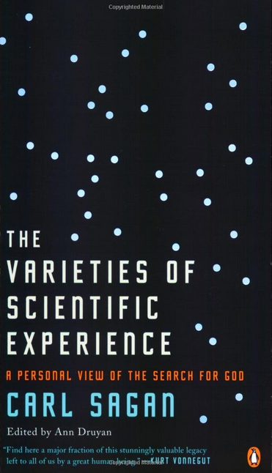 | Summary:  This work is a posthumous edition of noted scientist Carl Sagan's Gifford Lectures, given in 1985 at the University of Glasgow to mark the lectureship's centennial. The title, provided by his widow and longtime collaborator Ann Druyan, intends to call to mind another famous Gifford Lecture series by philosopher William James, later published as the classic The Varieties of Religious Experience. The title shift is both significant and suggestive. The lecture topics range widely over the field of religion and science; Sagan sketches the origins of modern science, the issues within the intelligent design debate, the evolutionary and organic aspects of the solar system, the myths and possibilities of extraterrestrial life, and the nature of God and human religious experience. Not unexpectedly, Sagan espouses a definite viewpoint here, with empirical science (a kind of "informed worship" for Sagan) clearly in the driver's seat. Religious perspectives ride in the back, rather than alongside in the front passenger seat helping to navigate the journey through the cosmos. But at least Sagan acknowledges both are making the same journey.  For those willing to accept Sagan's premise, this is a clear, straightforward introduction to the subject.  Summing Up: Recommended. All levels. C. S. Langton Principia College

- Frazier, Kendrick. Science Under Siege: Defending Science, Exposing Pseudoscience. Amherst, N.Y.: Prometheus Books, 2009. Print. pp. 370.
Summary:

For more than thirty years, The Skeptical Inquirer has steadfastly championed science and reason and been the leading voice for reliable scientific examination of the paranormal and other questionable claims popularized by the media and mass culture. In this new collection of outstanding recent articles, editor Kendrick Frazier has selected some of the best writing on topics of current interest. Among the highlights are: "A Skeptical Look at September 11th" which prompted a drove of responses (many angry) and was selected by Richard Dawkins for the Best Science and Nature Writing of 2003. Carl Sagan's final question-and-answer piece on the topic of science and skeptical inquiry. Ann Druyan's beautifully expressed "Science, Religion, Wonder, and Awe." NASA scientist Stuart Jordan's excellent appraisal of the scientific evidence for global warming, which prompted much critical response and led to another follow-up article. Five articles on the evolution vs. intelligent design controversy Two physicians' articles that strongly defend the value of vaccinations and critique the anti-vaccination movement Other distinguished contributors include Mario Bunge, Martin Gardner, Ray Hyman, Paul Kurtz, Chris Mooney, Joe Nickell, Stephen Pinker, and many others. This excellent collection of stimulating articles exploring science and skeptical inquiry, public controversies, and investigating pseudoscientific claims is a must for scientists, educators, skeptics, and everyone concerned about scientific literacy.

- Petersen, Carolyn Collins. Astronomy 101: From the Sun and Moon to Wormholes and Warp Drive, Key Theories, Discoveries, and Facts About the Universe. Avon, Massachusetts: Adams Media, 2013. Print. pp. 288.
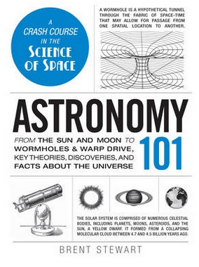 | Summary:  Explore the curiosities of our galaxy! Too often, textbooks obscure the beauty and wonder of outer space with tedious discourse that even Galileo would oppose. Astronomy 101 cuts out the boring details and lengthy explanations, and instead, gives you a lesson in astronomy that keeps you engaged as you discover what's hidden beyond our starry sky. From the Big Bang and nebulae to the Milky Way and Sir Isaac Newton, this celestial primer is packed with hundreds of entertaining astronomy facts, charts, and photographs you won't be able to get anywhere else. So whether you're looking to unravel the mystery behind black holes, or just want to learn more about your favorite planets, Astronomy 101 has all the answers--even the ones you didn't know you were looking for.

- Dean, Cornelia. The New York Times Book of Physics and Astronomy: More than 100 years of covering the Expanding Universe. New York: Sterling, 2013. Print. pp. 557.
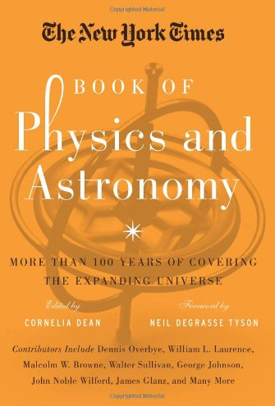 | Summary:  "The best on physics and astronomy from The New York Times! The newspaper of record has always prided itself on its coverage of physics and astronomy, realms that have dominated science and the popular imagination like few others, and these 125 articles from its archives feature such esteemed names as Malcolm W. Browne, James Glanz, George Johnson, William L. Laurence, Dennis Overbye, Walter Sullivan, and more. From the discovery of distant galaxies and black holes to the tiny interstices of the atom, these articles cover more than 100 years of breakthroughs, discoveries, setbacks, and mysteries solved and unsolved"-- Provided by publisher.

- Scott, Carole. Starfinder: The Complete Beginner’s Guide to the Night Sky. New York: Dorling Kindersley Publishing, 2013. Print. pp. 124.
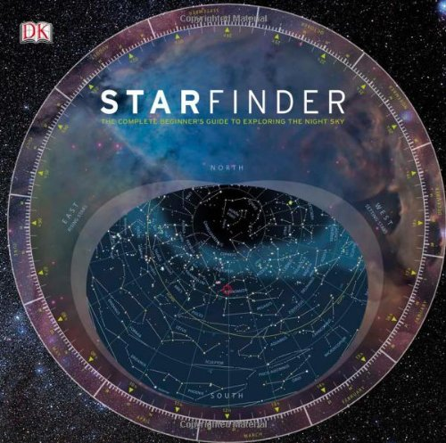 | Summary:  "Starfinder is the ideal introduction to the night sky and how to observe it. It explains all you need to know about the Solar System and the rest of the Universe and shows you how to find and recognize objects such as stars and planets. To help you build your astronomy skills, it includes a month-by-month observation guide, a detailed directory of all 88 constellations, and a planisphere that reveals the night sky at any time of the year. The planisphere is a circular map of the stars with a rotating window on top. By turning the window, it can be set to show the stars as they will appear aat a particular time on any chosen night of the year."--Cover, p. [4]

- Sagan, Carl. Billions and Billions: Thoughts on Life and Death at the Brink of the Millennium. New York: Random House, 1997. Print. pp. 241.
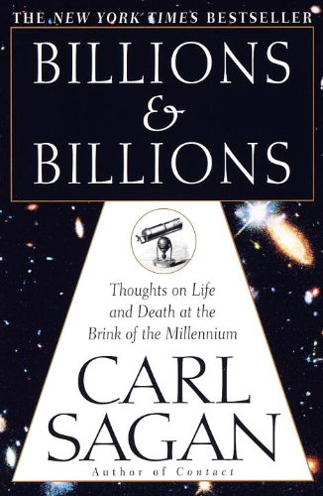 | Summary:  In this book, his last, Carl Sagan shows once again his extraordinary ability to interpret the mysteries of life and the majesty of the universe for the general reader. Brilliant, eloquent, and imbued with Sagan's uniquely childlike sense of awe, this entertaining collection of essays captures the authors spirit at its best. In Billions and Billions Sagan applies what we know about science, mathematics, and space to everyday life, as well as to the exploration of many essential questions concerning the environment and our future. Ranging far and wide in subject matter, he takes his readers on a soaring journey, from the invention of chess to the possibility of life on Mars, from Monday Night Football to the relationship between the United States and Russia, from global warming to the abortion debate. And, on a more intimate note, we are given a rare glimpse of the author himself as he movingly describes his valiant fight for his life, his love of his family, and his personal beliefs about death and God. Throughout these essays, Sagan provides clarity and understanding for an audience eager to make sense of the world around it as it prepares for the challenges of the coming millennium, and in the process he illuminates his strongly held belief that we have the ability to change the world and our lives for the better. Sagan has said, We make our world significant by the courage of our questions and by the depth of our answers. With this book, as in his magnificent career, he makes this world significant indeed.

REFERENCE BOOKS: Required: 8 -10 annotated
- Sagan, Carl. Conversations with Carl Sagan. University Press of Mississippi, 2006. Print. pp. 167.
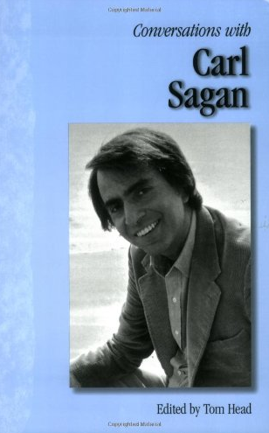 | Summary:  Though a well-regarded physicist Carl Sagan (1934-1996) is best known as a writer of popular nonfiction and science fiction and as the host of the PBS series Cosmos. Through his writings and spoken commentary, he worked to popularize interests in astronomy, the universe, and the possibility of extraterrestrial life.  From the beginning of his public career, when he co-wrote Intelligent Life in the Universe to the very end as he worked on the 1997 film adaptation of his novel Contact, these subjects absorbed him. This interest in space was rooted in his understanding of the smallness and vulnerability of humanity measured against the immense size and power of the universe. This profound philosophical humility, mixed with personal exuberance, comes through in Conversations with Carl Sagan.  In interviews and profiles, Sagan discusses with verve a wide variety of topics--the environment, nuclear disarmament, religion, politics, extraterrestrial life, astronomy, physics, robotics. Whether he is discussing his science fiction or his well-researched nonfiction works, his voice embraces reason and skepticism. This volume shows how Sagan, a lifelong skeptic, refined his views and expressed amazement that Earth, for all his belief in extraterrestrial life, encompasses everything about which he cared.

- Sagan, Carl. Comet. New York: Ballantine, 1997, Print. pp. 398.
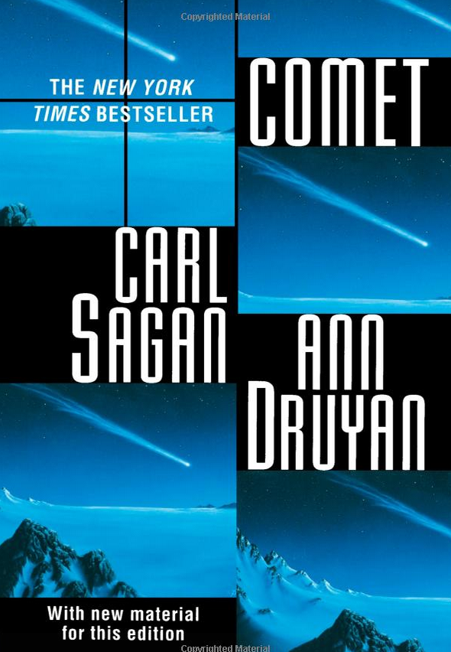 | Summary:  WHAT ARE THESE GRACEFUL VISITORS TO OUR SKIES? WE NOW KNOW THAT THEY BRING BOTH LIFE AND DEATH AND TEACH US ABOUT OUR ORIGINS. Comet begins with a breathtaking journey through space astride a comet. Pulitzer Prize-winning astronomer Carl Sagan, author of Cosmos and Contact, and writer Ann Druyan explore the origin, nature, and future of comets, and the exotic myths and portents attached to them. The authors show how comets have spurred some of the great discoveries in the history of science and raise intriguing questions about these brilliant visitors from the interstellar dark. Were the fates of the dinosaurs and the origins of humans tied to the wanderings of a comet? Are comets the building blocks from which worlds are formed? Lavishly illustrated with photographs and specially commissioned full-color paintings, Comet is an enthralling adventure, indispensable for anyone who has ever gazed up at the heavens and wondered why.

- Willis, Jim. Armageddon Now: The End of the World A to Z. Detroit: Visible Ink Press, 2006. Print. pp. 450.
Summary:

Is it the end of the world as we know it? According to a considerable minority in this country alone, the end just may be near. How else can we explain the mind-boggling popularity of such prophets as Nostradamus and Edgar Cayce? If your library caters to the converted, you may consider purchasing this A-to-Z overview of the history of apocalyptic beliefs. In 200 entries, the Willises (The Religion Book: Places, Prophets, Saints, and Seers) tackle such topics as collisions with asteroids, nuclear war, global warming, and more. (c) Copyright 2010. Library Journals LLC, a wholly owned subsidiary of Media Source, Inc. No redistribution permitted. –Library Journal

- Turco, Richard P., Earth Under Siege: From Air Pollution to Global Change. Oxford; New York: Oxford University Press, 1997. Print. pp. 527.
Summary:

This acclaimed book examines one of the most important problems facing our modern technological age: environmental pollution. Written to inform general readers--including future policy makers, business administrators, and political leaders--the text offers a comprehensive description of environmental systems, providing a basic understanding of how the world around us works and how human activities affect it. Building on a popular course he taught at UCLA, Richard Turco clearly explains underlying environmental principles and processes including the role of evolutionary forces in shaping the environment, Earth's energy balance, and biogeochemical cycles. Against this background, Turco surveys local and regional problems, including indoor air pollution, smog, and acid rain, identifying the sources and fates of pollutants and examining human exposure to natural and manmade toxins. He then addresses global issues such as stratospheric ozone depletion and greenhouse climate warming and describes responses to these threats in the form of "global environmental engineering." Now in its second edition, Earth Under Siege has been revised and updated to reflect advances in knowledge and progress in regulation. It offers a comprehensive overview of environmental issues for students in the physical and life sciences, geography, economics, engineering, environmental management and law, policy studies, and social and health sciences.

- Maran, Stephen P., The Astronomy and Astrophysics Encyclopedia. New York: Van Nostrand Reinhold, c. 1992. Print. pp. 1002.
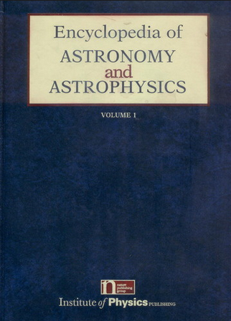 | Summary:  There have been a number of astronomy encyclopedias published recently but this one emerges as the most authoritative, academically oriented. Most of the others have been popular in approach, with a good number of color pictures. The Academic Press Encyclopedia of Astronomy and Astrophysics, ed. by R.A. Meyers (1989), the closest comparison to the present volume, is simply a compilation of 41 articles on astronomy reprinted from that publisher's 15-volume Encyclopedia of Physical Science and Technology, ed. by R. A. Meyers (1987). The more than 400 contributors to this Van Nostrand Reinhold encyclopedia include many eminent authorities in astronomy. The 403 articles are well written, more authoritative, more current, and contain more information than those in the Academic Press publication: this volume is not directed simply to the general reader as most other astronomy encyclopedias have been. There are many excellent illustrations and pictures. That none of the pictures are in color does not hinder the presentation of the material. Each article includes cross-references and a current bibliography with many citations dated as late as 1990. An excellent index is also included. This volume is now the premier encyclopedia of astronomy, is well worth its price, and should be considered for purchase by every academic and public library.  -J. O. Christensen, Brigham Young University.

- Sagan, Carl. Shadows of Forgotten Ancestors: A Search for Who We Are. New York: Random House, c1992. Print. pp. 505.

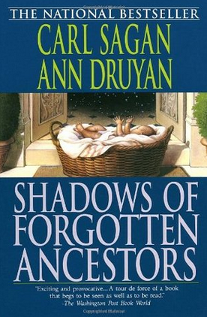 | Summary:  In a leisurely, lyrical meditation on the roughly four-million-year span since life dawned on Earth, Sagan and Druyan (Comet) argue that territoriality, xenophobia, ethnocentrism, occasional outbreeding and a preference for small, semi-isolated groups are elements in a survival strategy common to many species, including Homo sapiens. Yet society's problems, they assert, increasingly demand global solutions and require a dramatic, strategic shift that the authors optimistically believe humankind is capable of achieving. This engaging, humane odyssey offers a stunning refutation of the behavioristic worldview with its mechanistic notion that animals (except for humans) lack conscious awareness. Writing with awe and a command of their material, the husband-wife team cover well-trod terrain while they discuss the evolution of Earth's atmosphere and life forms, the genetic code, the advantages of sexual reproduction. The last third of the book, dealing with chimpanzees, baboons and apes, is the most interesting. Sagan and Druyan find chimps' social life ``hauntingly familiar'' with its hierarchy, combat, suppression of females and chimps' remarkable ability to communicate through symbols. First serial to Parade. (Oct.) (c) Copyright PWxyz, LLC. All rights reserved

- Tyson, Neil deGrasse, Soter, Steven et al. Cosmic Horizons: Astronomy at the Cutting Edge. New York: New Press: Distributed by W.W. Norton, c2001. pp. 253.
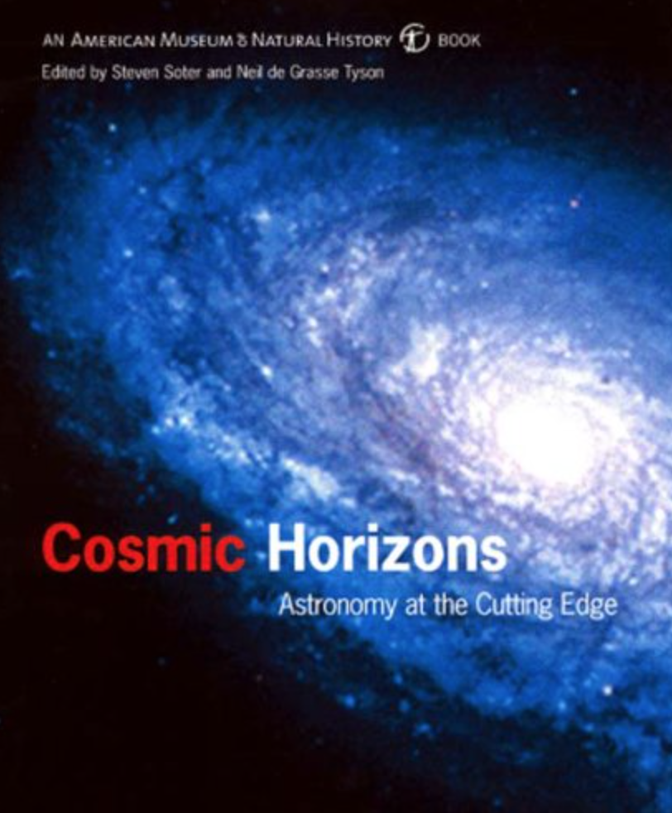 | Summary:  NASA scientists and astronomers from some of the most prestigious universities in the US describe recent discoveries of modern astronomy and astrophysics--from dark matter and gamma ray bursts to neutrino observatories and the latest news from SETI. In all there are 40 short pieces (including profiles of astronomers and case studies) as well as introductions to each of the six sections. The numerous color illustrations include Hubble images of planets and galaxies and computer models showing the impact of Comet Shoemaker-Levy 9 on Jupiter. c. Book News Inc.

- Bilson, Elizabeth M., Terzian, Yervant. Carl Sagan’s Universe. Cambridge, U.K.; New York, NY, USA: Cambridge University Press, 1997. pp. 282.
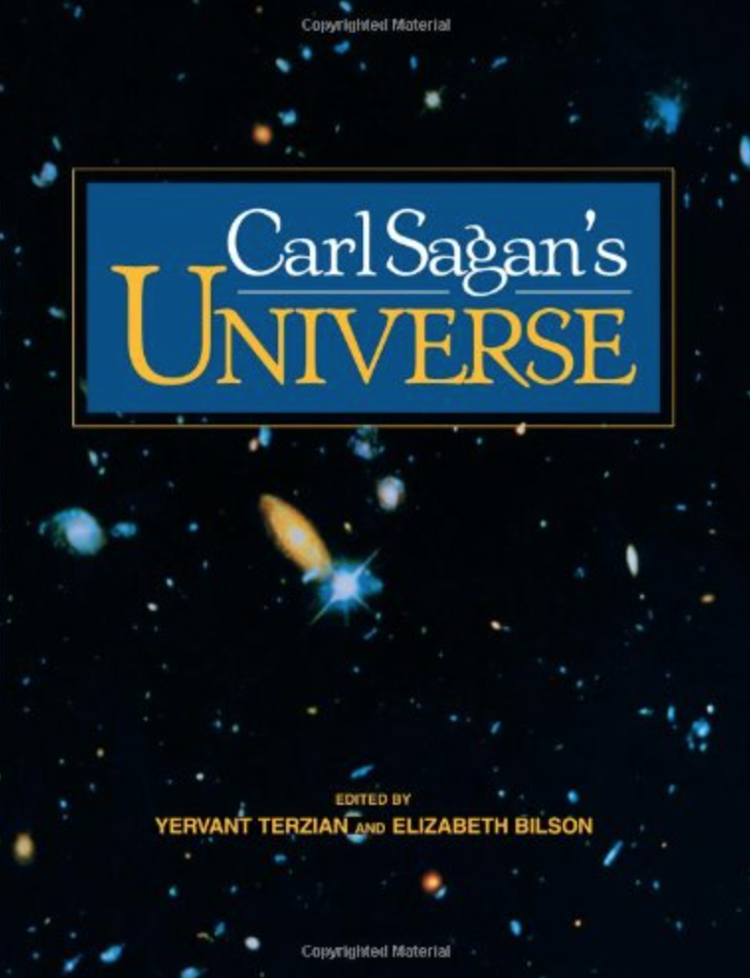 | Summary:  Carl Sagan's many contributions to science and society have been profound and far-reaching, influencing millions of people around the world. He carried out significant research in planetary science, was closely associated with the US space program, created the highly acclaimed television series Cosmos, and was the Pulitzer Prize-winning author of many best-selling popular science books. Carl Sagan's Universe is a fascinating and beautifully illustrated collection of articles by a distinguished team of authors, and covers the many fields of science, education, policy making, and related areas in which Sagan worked. The book is divided into four sections, the first two of which provide an absorbing overview of the US space program (as well as a complementary account of the Russian program), and of the history and current status of the search for extraterrestrial life. The final two sections deal with the importance of science education in the successful development of a technological society, and of the shaping of science policy in tackling the problems facing us today. Also included is a separate chapter by Sagan himself, discussing the place and role of our planet and mankind in the universe. Written in honour of Carl Sagan's many achievements, this book will fascinate and reward anyone interested in planetary science and exploration, the search for extraterrestrial life, or the role of science in the modern world.

ARTICLES on Carl Sagan: Required: 8 -10 annotated

- “Carl Sagan.” Skeptic 19.1 (2014): 64-73. Academic Search Complete. Web. 15 Apr. 2015.

Summary: The article focuses on the story of astronomer Carl Sagan and dedicated his life to two astonishing projects that includes teaching millions of regular Folks about the power and beauty of science and searching for evidence of extraterrestrial life. It further discusses Sagan's documentary television series Cosmos.

- “Carl Sagan, Cosmos, and Abortion Rights.” Free Inquiry Vol 34 Issue 4. (June/July 2014): p 56 – 56. 1 p. Academic Search Complete. Web. 15 Apr. 2015.

Summary: The article focuses on Astronomist, Carl Sagan, a member of the National Advisory Board of Americans for Religious Liberty (ARL) who played a significant role in abortion rights. Topics discussed by the author include the premiere on the continuation of Sagan's classic 1980 television series "Cosmos: A Space time Odyssey" on March 9, 2014 and his article "Abortion: Is It Possible to Be Both 'Pro-Life' and 'Pro-Choice?" co-authored with his wife Ann Druyan in "Parade" magazine on April 22, 1990.

- “Long-range consequences of interplanetary collisions.” Issues in Science and Technology Vol. 10 Issue 4 (Summer 1994): p 67. 6p. Academic Search Complete. Web. 15 Apr. 2015.

Summary: Discusses the implications of the Earth's possible interplanetary collisions with other heavenly bodies. A discusses a history of comet collisions, assessment of risks, possible counter-threats and prospects of collisions.

- “Aliens, the Cosmos, and the Foundations of Political Life.” Perspectives on Political Science. Vol. 28 Issue 3 (Summer 1999): p 131. 5p. Academic Search Complete. Web. 15 Apr. 2015.

Summary: Discusses the ideas of three scientists on extraterrestrial beings, the universe and the meaning of political life. Examination on the claim of Carl Sagan that humans are wanderers by nature; Implications of Sagan's idea about the political nature of man; Analysis on the ideas of Paul Davies, a physicist, that contradicts the claims of Sagan; Discussion on the views of Walker Percy, a scientist-novelist, on the topic.

- Krauss, Lawrence M. "Scientists As Celebrities: Bad For Science Or Good For Society?." Bulletin Of The Atomic Scientists 71.1 (2015): 26-32. Academic Search Complete. Web. 28 Apr. 2015.

Summary: The author explores the reasons why scientists such as Albert Einstein, Richard Feynman, Carl Sagan, Stephen Hawking, and Neil deGrasse Tyson became celebrities, as well as sharing his own experience. He describes how public acclaim is often uncorrelated to scientific accomplishment and depends more on communication skills and personality traits. Nevertheless, he argues that the entire scientific community benefits when credible scientists gain a wider audience, and that celebrity is an opportunity that should not be squandered. Scientists who become recognizable have a chance and perhaps even a responsibility, which they have often exploited, to promote science literacy, combat scientific nonsense, motivate young people, and steer public policy discussions toward sound decision making. [ABSTRACT FROM PUBLISHER]

- Druyan, Ann. "Ann Druyan Talks About Science, Religion, Wonder, Awe … And Carl Sagan." ETC: A Review Of General Semantics 63.1 (2006): 25-35. Academic Search Complete. Web. 28 Apr. 2015.

Summary: The article presents views on the relationship and conflict between science and religion. It raised the argument of why people separate the scientific methodology as a way of searching for truth. It also addresses the tragedy that science ceded the spiritual uplift of its central revelations: the vastness of the universe, the immensity of time, and the relatedness of all life.

- Sagan, Carl. "The God Hypothesis." Skeptic 13.1 (2007): 39-45. Academic Search Complete. Web. 28 Apr. 2015.

Summary: An excerpt from the book "The God Hypothesis," by Carl Sagan is presented. The following excerpt is from Chapter 6, "'the God Hypothesis,” from The Varieties of Scientific Experience: A Personal View of the Search for God, by Carl Sagan, edited by Ann Druyan. Each (of the chapters represents a lightly-edited transcription of the original lectures written and present by Cari Sagan at the University of Glasgoiv for the 1985 Gifford Lectures on Natuml Theology.

This series has hosted some of the greatest thinkers of the 20th century including Arthur Eddington, Werner Heisenherg, Niels Bohr, Alfred North Whitehead, and Albert Schweitzer In her introduction to the volume. Sagan's long time collaborator and wife Ann Druyan iirites:

"Carl saw these lectures as a chance to set down in detail his understanding of the relationship between religion and science also something of his own search to understand the nature of the sacred."

Druyan attended every lecture, "and more than twenty years later what remains with me was his extraordinary' combination of principled, crystal clear advocacy coupled with reflect and tenderness towards those who did not share his men's. "Those who recall the inimitable voice of Sagan with his punched syllables and dramatic pauses will hear it again in these chapters. "There was plenty of laughter during these lectures,"Druyan recalls, "but also the kind of pin drop silence that comes when the audience and the speaker are united in the thrall of an idea." There is, arguably no more enthralling idea than that of God, which Sagan characteristically addressed in a rigorously logical and scientific manner. I thank Penguin Press and Ann Druyan for the opportunity to publish this excerpt, but more importantly for making this treasure of thought available to the world.

- Sagan, Carl. "Why Send Humans To Mars? (Cover Story)." Issues In Science & Technology 7.3 (1991): 80. Academic Search Complete. Web. 28 Apr. 2015.

Summary: Discusses the issue of manned missions to Mars as advocated by Carl Sagan, the David Duncan professor of Astronomy and Space Sciences at Cornell University. President George Bush's announcement of a long-term direction for the U.S. Space Exploration Initiative (SEI). Key to getting to Mars is to save money; Alternative technologies; International cooperation; Standard justifications; Steps for the here-and-now.

WEB RESOURCES on Carl Sagan: Required: 8 -10 annotated, of these 4 – 6 (professional organizations, digital or archival collections, film/audio resources)

- Varieties of Scientific Experience: Carl Sagan on Science and God. By Maria Popova
Website: Brain Pickings, December 20, 2013

http://www.brainpickings.org/2013/12/20/carl-sagan-varieties-of-scientific-experience/

- Carl Sagan’s Undergrad Reading List: 40 Essential Texts for a Well-Rounded Thinker. By Open Culture. Website. July11, 2012.

http://www.openculture.com/2012/07/carl_sagans_undergrad_reading_list_from_plato_and_shakespeare_to_huxley_and_gide.html

- The Carl Sagan Portal
http://www.carlsagan.com

Summary: You have arrived at the gateway to the Carl Sagan sites. Our mission is to awaken the broadest possible public to the wonders of nature as revealed by science.

- Carl Sagan Center at The Seti Institute
http://www.seti.org/carlsagancenter

Summary: The center brings together leading researchers in astrobiology, the study of life in the universe. Astrobiology uses modern science to seek answers to the age-old questions: Where did we come from? Are We Alone?

Our team focuses on a wide set of disciplines ranging from observing and modeling the precursors of life in the depths of outer space to studies of Earth and its rich biological history. We seek to understand the concept of habitability, on our planet and elsewhere in the solar system. Many of our scientists participate as investigators in NASA space flight missions, as observers on some of the world’s finest telescopes, and as explorers probing life in inhospitable environments, including the Arctic, Antarctic, high mountains and the depths of the sea. Appropriate to the sweeping scope of this research, we have many partners including NASA, the National Science Foundation, and major universities.

- The Planetary Society
http://planetary.org

Summary: With your support, The Planetary Society sponsors projects that will seed innovative space technologies, nurtures creative young minds, and is a vital advocate for our future in space.

The Planetary Society, founded in 1980 by Carl Sagan, Bruce Murray, and Louis Friedman, to inspire and involve the world's public in space exploration through advocacy, projects, and education. Today, The Planetary Society is the largest and most influential public space organization group on Earth.

- The Voyager Golden Record
http://goldenrecord.org

Summary: The Voyager Golden Records are phonograph records which were included aboard both Voyager spacecraft, which were launched in 1977. They contain sounds and images selected to portray the diversity of life and culture on Earth, and are intended for any intelligent extraterrestrial life form, or for future humans, who may find them. The Voyager spacecraft are not heading toward any particular star, but Voyager 1 will be within 1.6 light-years of the star Gliese 445, currently in the constellation Camelopardalis, in about 40,000 years.

As the probes are extremely small compared to the vastness of interstellar space, the probability of a space-faring civilization encountering them is very small, especially since the probes will eventually stop emitting electromagnetic radiation meant for communication.

Carl Sagan noted that "The spacecraft will be encountered and the record played only if there are advanced space-faring civilizations in interstellar space. But the launching of this 'bottle' into the cosmic 'ocean' says something very hopeful about life on this planet." Thus the record is best seen as a time capsule.

- The Seth Macfarlane Collection of the Carl Sagan and Ann Druyan Archive, The Library of Congress
http://findingaids.loc.gov/db/search/xq/searchMfer02.xq?_id=loc.mss.eadmss.ms013113&_faSection=overview&_faSubsection=did&_dmdid=

Summary: The material documents Sagan’s energetic career as an astronomer, author, unrivaled popularizer of science and TV star, and it ranges from childhood report cards to college term papers to eloquent letters written just before his untimely death in 1996 at age 62. Also in the mix are files labeled F/C, for “fissured ceramics,” Sagan’s code name for letters from crackpots.

- Finding Our Place in the Cosmos: From Galileo to Sagan and Beyond, The Library of Congress
http://www.loc.gov/collections/finding-our-place-in-the-cosmos-with-carl-sagan/about-this-collection/

Summary: A thematic collection exploring changing models of the universe through time, ideas of life on other words and Carl Sagan’s place in the tradition of science. It features manuscripts, rare books, celestial atlases, newspaper articles, sheet music and movie posters.

- Library of Congress: Home movies of Carl Sagan’s Childhood
http://www.loc.gov/item/cosmos000112

- Symphony of Science by John D. Boswell featuring Carl Sagan
http://uchiblogo.uchicago.edu/archives/2009/09/sound_of_scienc.html
https://www.youtube.com/watch?v=zSgiXGELjbc

Summary: The Symphony of Science is a music project created by Washington-based electronic musician John D. Boswell. The project seeks to "spread scientific knowledge and philosophy through musical remixes." Boswell uses pitch-corrected audio and video samples from television programs featuring popular scientists and educators. The audio and video clips are mixed into digital mashups and scored with Boswell's original compositions. Two of Boswell's music videos, "A Glorious Dawn" and "We are All Connected", feature appearances from Carl Sagan, Richard Feynman, Neil deGrasse Tyson, Bill Nye, and Stephen Hawking. The audio and video is sampled from popular science television shows including Cosmos, The Universe, The Eyes of Nye, The Elegant Universe, and Stephen Hawking's Universe.

- "The Music of Cosmos: Selections from The Score of the PBS Television Series 'Cosmos' by Carl Sagan." New York: RCA Victor, c1981. LP Vinyl.
https://chipublib.bibliocommons.com/item/show/669396081_the_music_of_quotcosmosquot

- A recording of Carl Sagan saying the word ‘billions’ once, but stretched for an entire hour
https://soundcloud.com/johnkannenberg/1-hour-sagan-billion

- Correspondence between Neil Degrasse Tyson and Carl Sagan, 1975- 1976
http://www.loc.gov/item/cosmos000055/

- Cosmos: A Personal Voyage, by Carl Sagan. T.V. Series, 1981 (Full series on Youtube)
https://www.youtube.com/watch?v=dADUBcoEEHw

Summary: Soter, with Sagan as presenter. It was executive-produced by Adrian Malone, produced by David Kennard, Geoffrey Haines-Stiles, and Gregory Andorfer, and directed by the producers, David Oyster, Richard Wells, Tom Weidlinger, and others. It covers a wide range of scientific subjects, including the origin of life and a perspective of our place in the universe.

Astronomer Dr. Carl Sagan is host and narrator of this 13-hour series that originally aired on Public Broadcasting Stations in the United States. Dr. Sagan describes the universe in a way that appeals to a mass audience, by using Earth as a reference point, by speaking in terms intelligible to non-scientific people, by relating the exploration of space to that of the Earth by pioneers of old, and by citing such Earth legends as the Library of Alexandria as metaphors for space-related future events. Among Dr. Sagan's favorite topics are the origins of life, the search for life on Mars, the infernal composition of the atmosphere of Venus and a warning about a similar effect taking place on Earth due to global pollution and the "greenhouse effect", the lives of stars, interstellar travel and the effects of attaining the speed of light, the danger of mankind technologically self-destructing, and the search, using radio technology, for intelligent life in deep space.

- Carl Sagan's last interview with Charlie Rose (Full interview), May 27, 1996
https://www.youtube.com/watch?v=U8HEwO-2L4w

Publications by Carl Sagan – 1966 – 2006
- Sagan, Carl; Leonard, Jonathan Norton (1966). Planets. Life Science Library. Editors of Life. New York: Time, Inc. LCCN 66022436.OCLC 346361.
- Shklovskii, I.S. (1966) [Originally published 1962 as Вселенная, жизнь, разум; Moscow: USSR Academy of Sciences Publisher].Intelligent Life in the Universe. Authorized translation by Paula Fern. San Francisco: Holden-Day, Inc. LCCN 64018404. OCLC 317314.
- Page, Thornton, eds. (1972). UFO's: A Scientific Debate. Ithaca, NY: Cornell University Press. ISBN 0-801-40740-0. LCCN 72004572.OCLC 415373.\
- ed. (1973). Communication with Extraterrestrial Intelligence (CETI). Cambridge, MA: MIT Press. ISBN 0-262-19106-7. LCCN 73013999.OCLC 700752.
- Bradbury, Ray; Clarke, Arthur C. et al. (1973). Mars and the Mind of Man (1st ed.). New York: Harper & Row. ISBN 0-060-10443-0.LCCN 72009746. OCLC 613541.
- (1973). The Cosmic Connection: An Extraterrestrial Perspective. Produced by Jerome Agel (1st ed.). Garden City, NY: Anchor Press.ISBN 0-385-00457-5. LCCN 73081117. OCLC 756158.
- (1975). Other Worlds. Produced by Jerome Agel. Toronto, NY: Bantam Books. ISBN 0-552-66439-1. OCLC 3029556.
- (1977). The Dragons of Eden: Speculations on the Evolution of Human Intelligence (1st ed.). New York: Random House. ISBN 0-394-41045-9. LCCN 76053472. OCLC 2922889.
- Drake, F. D.; Lomberg, Jon et al. (1978). Murmurs of Earth: The Voyager Interstellar Record (1st ed.). New York: Random House. ISBN 0-394-41047-5. LCCN 77005991. OCLC 4037611.
- (1979). Broca's Brain: Reflections on the Romance of Science (1st ed.). New York: Random House. ISBN 0-394-50169-1.LCCN 78021810. OCLC 4493944.
- (1980). Cosmos (1st ed.). New York: Random House. ISBN 0-394-50294-9. LCCN 80005286. OCLC 6280573.
- Ehrlich, Paul R.; Kennedy, Donald et al. (1984). The Cold and the Dark: The World after Nuclear War: The Conference on the Long-Term Worldwide Biological Consequences of Nuclear War. Foreword by Lewis Thomas (1st ed.). New York: W. W. Norton & Company. ISBN 0-393-01870-9. LCCN 84006070. OCLC 10697281.
- Druyan, Ann (1985). Comet (1st ed.). New York: Random House. ISBN 0-394-54908-2. LCCN 85008308. OCLC 811602694.
- (1985). Contact: A Novel. New York: Simon & Schuster. ISBN 0-671-43400-4. LCCN 85014645. OCLC 12344811.
- Turco, Richard (1990). A Path Where No Man Thought: Nuclear Winter and the End of the Arms Race (1st ed.). New York: Random House.ISBN 0-394-58307-8. LCCN 89043155. OCLC 20217496.
- Druyan, Ann (1992). Shadows of Forgotten Ancestors: A Search for Who We Are (1st ed.). New York: Random House. ISBN 0-394-53481-6. LCCN 92050155. OCLC 25675747.
- (1994). Pale Blue Dot: A Vision of the Human Future in Space (1st ed.). New York: Random House. ISBN 0-679-43841-6.LCCN 94018121. OCLC 30736355.
- (1995). The Demon-Haunted World: Science as a Candle in the Dark (1st ed.). New York: Random House. ISBN 0-394-53512-X.LCCN 95034076. OCLC 779687822. (Note: errata slip inserted.)
- Druyan, Ann (1997). Billions and Billions: Thoughts on Life and Death at the Brink of the Millennium (1st ed.). New York: Random House.ISBN 0-679-41160-7. LCCN 96052730. OCLC 36066119.
- (2006) [Edited from 1985 Gifford Lectures, University of Glasgow]. Druyan, Ann, ed. The Varieties of Scientific Experience: A Personal View of the Search for God. New York: Penguin Press. ISBN 1-59420-107-2. LCCN 2006044827. OCLC 69021064.

Poundstone 1999, pp. 363–364, 374–375
"Carl Sagan". Internet Accuracy Project. Grandville, MI: Internet Accuracy Project. Retrieved August 22, 2012.
Davidson, Keay (1999). Carl Sagan: A Life. New York: John Wiley & Sons.

